# Linux Lab 4 - Commands, Help, Paths and Executables

## Reading

Read Chapter 5 in “The Linux Command Line,” pp 39 - 47 in the printed version or pp 42 - 53 in the pdf. Feel free to run any of the examples in a terminal on your Ubuntu/CentOS VM.

## Part 1 - Getting Assistance

When you type a command at the terminal, like cd or gedit, the code that you are executing can come from several places; these are listed at the top of page 40 in the reading. Commands may act differently and have differing amounts of assistance, depending on where they come from.

### Shell built-ins

Our VM uses BASH (/bin/bash) as its default shell for logins. Another common shell for users who access a variety of distributions and don’t always know what distribution they will be on (attackers and penetration testers) is the Bourne shell, or sh (/bin/sh.) The Bourne shell (and variants) is small shell that strictly follows the POSIX standard and works pretty much the same everywhere.

1. One of the commands we have been using frequently is cd. Use the type command to see what kind of command it is.  
   type cd
2. Assistance for shell built-ins is usually found by typing help [command name]. Try that now on a command that you know is a shell built-in.
3. Shell built-ins may not support the help options -h or --help. You may just get an invalid option message and usage instructions, which are the most abbreviated kind of assistance. Try typing [command name] -h and [command name] --help for a command you know is a shell built-in.
4. Shell built-ins may not have manual pages. Try running man [command name] on a command you know is a shell built-in.

### Executable programs

This category includes compiled binary programs, as well as scripts written in Python, Perl, BASH, etc. Two things they have in common are that their code is kept in a file on the file system, and that file is marked with the executable permission. The amount of assistance available varies greatly depending on who wrote the code. Formally published code generally has several varieties of help; a script you wrote last year and neglected to document may have no help at all.

1. Use the type command to verify that cp and gedit are files. Then use ls -l /bin/cp and ls -l /usr/bin/gedit to examine the executable bits in their file permissions. Your terminal will use green to signify that cp and gedit are executable.
2. Try the assistance options -h or --help for cp or gedit as well as the man command. You should find extensive assistance.

### Alias

An alias is a string that often calls an existing command with convenient options already selected, although it may be group of commands as well. An alias can reduce our typing load, but it can also be used by an attacker to fool us into executing something we do not want. It is good to know what aliases are in your environment. The assistance you get with an alias will be the same as that available with the application the alias calls. While we are here though, let’s look a little deeper.

1. When we use ls for listing directories, we’re running a command, aren’t we? See if that is true by running  
   type ls  
    It turns out that we’ve been executing an alias all along. The which command will give you the alias information as well as the absolute path to the binary file for ls. Run ls -la on your current directory or a directory that has sub-directories or executables, so you see the color output. Then run ls -la using the absolute path (remember the absolute path starts with “/”). You should be able to tell the difference.
2. The command alias will show you what aliases are active in your environment. Try it now. You should see some handy aliases for ls. One will list hidden files (almost all files) and the other will give you a long listing of all files (the exact results will differ between CentOS and Ubuntu.) Remember them, as they will save typing. If you are on another distribution that does not have those aliases, you can easily create them. For example, Fedora has a nice alias to list only hidden files, l. You can make your own hidden files alias in Ubuntu by entering the command  
   alias l.= 'ls -d .* '.

## Part 2 - Paths, or where is the executable?

We have already seen that there may be more than one way to execute code (ls the alias, and /bin/ls the application), and there may be several copies of an application in our file system. The type command is helpful, and it has a cousin called which. The which command gives us the absolute path to the file that would be executed if we type a command, assuming there is no alias for that command. For instance,  
  
this tells us that the file we will run for ls is /bin/ls. Suppose there are several copies of ls? Which one runs? The answer is in the PATH environment variable. To see the contents of PATH, execute  
echo $PATH  
The “$” tells BASH that we want the contents of the PATH variable; otherwise it will just repeat whatever we typed.  


When you type “ls” the shell checks each directory in the path, in order, looking for a file named “ls.” It executes the first one it finds.

1. Look for a file called “ls” in the path directories. First try the command  
   ls /usr/local/sbin/ls  
   Nothing…so ls is not in the first directory of the path. Now try each directory in the path until you find ls.
2. Now, let’s have some fun. Use sudo nano (or sudo gedit if you like) to create a file in /usr/local/bin with a filename “ls” and content like this:

#!/bin/bash  
echo “Ha! Gotcha! You thought this was ls!”  
Then make the file executable with

sudo chmod +x /usr/local/sbin/ls  


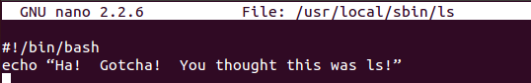

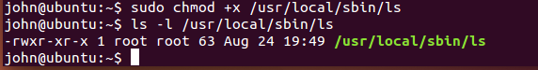

Then exit your terminal, start a new terminal and try to use ls. What happens and why?

1. Once you are done, fix your VM by using:  
   sudo rm /usr/local/sbin/ls

## Part 3 - Executing from the current directory

If you examine your PATH variable (echo $PATH) you will see that it does not include the “.” character, which signifies the current directory. If it did, an attacker could do the same attack we demonstrated in step 10 without needing to use sudo and your password; they could put a fake “ls” in your home directory, for example. However, you will often wish to execute scripts you’ve written from the same directory that holds them. Here is how to do it.

1. Change directories to your home directory, if you aren’t there already. Create a simple script using nano or gedit (no sudo needed this time.)  
   

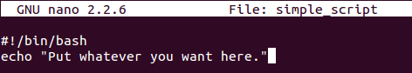

1. Here I used cat to verify that my script was correct and used chmod to make it executable.  
   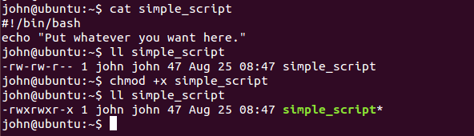
2. Try to execute the script by typing its name. It should fail. You may notice that even tab-complete does not work.  
   
3. The reason it fails is that the current directory is not in the PATH variable. It will execute if you explicitly specify the path to the script, however. Any of the following should work--try them.  
   ./simple_script  
   /home/[your username]/simple_script  
   ~/simple_script  
   Obviously, “./” is easier so most people use that.

# Hand in

1. In step 10, why did your script run instead of the ls executable?
2. What are the two steps you need to perform when you want to execute a script you’ve written from your current directory?